Customer Segmentation & Churn Pattern Analytics in European Banking
By Jitin Raju

Abstract
Customer churn remains one of the most pressing challenges in the banking sector. This study explores churn patterns using a European bank dataset, applying segmentation techniques and visual analytics to uncover demographic, financial, and behavioral drivers of customer attrition. The findings highlight key risk groups and provide actionable insights for customer retention strategies. This project was carried out under the guidance of Mr. Saiprasad Kagne.

- Introduction
Customer churn has become one of the most pressing challenges in the modern banking industry. While attracting new customers is important, retaining existing ones often proves more valuable in the long run. Every customer who leaves represents not only a loss of potential lifetime value but also an increase in acquisition costs and revenue instability. Banks face significant losses when customers discontinue their services, making it critical to understand who is leaving and why.
This project focuses on customer segmentation and churn pattern analytics in European banking, aiming to bridge that gap. By examining customer behavior across demographics, geography, and financial profiles, the study seeks to identify which groups are most at risk of leaving and how churn differs among them. Instead of treating churn as a single number, the project emphasizes a segmentation-driven approach—looking at age brackets, tenure with the bank, credit scores, and account balances to reveal meaningful insights.
To achieve this, the project uses a dataset that captures demographic, financial, and engagement variables. The analysis is structured to balance technical rigor with practical readability, ensuring that findings are accessible to both academic readers and banking professionals.
The ultimate goal is to provide banks with a clearer picture of their customer base and the risks they face. With this understanding, decision-makers can design more targeted retention strategies, strengthen customer relationships, and reduce the hidden costs of churn. Beyond its immediate business value, the project also highlights how structured analytics can transform raw data into actionable knowledge, supporting both strategic planning and customer-centric innovation in the financial sector.
1.1 Problem Statement
Despite having rich customer-level data, banks face challenges in:
• Identifying high-risk customer segments
• Understanding churn differences by geography and demographics
• Quantifying the financial profile of churned customers
1.2 Project Objectives
• Measure overall churn rate
• Identify churn distribution across customer segments
• Compare churn behavior across European regions
1.3 Secondary Objectives
• Understand churn among high-value customers
• Evaluate engagement and tenure patterns
• Support strategic planning and marketing decisions
1.4 Dataset Description
Column | Description
CustomerId | Unique customer identifier
Surname | Customer surname
CreditScore | Customer creditworthiness
Geography | France, Spain, Germany
Gender | Male / Female
Age | Customer age
Tenure | Years with the bank
Balance | Account balance
NumOfProducts | Number of bank products
HasCrCard | Credit card ownership
IsActiveMember | Activity indicator
EstimatedSalary | Estimated annual salary
Exited | Churn indicator (target)

- Methodology
This study was carried out using a Jupyter Notebook environment, which allowed for interactive coding and visualization. The analysis was scripted in Python, making use of widely adopted data analysis libraries such as pandas, numpy, matplotlib, and seaborn. These tools provided the foundation for cleaning the dataset, segmenting customers, and producing visual insights into churn behavior.
The workflow followed a structured sequence:
- Data Ingestion and Validation The dataset was first loaded and inspected to understand its structure. Checks were performed for missing values, duplicate records, and consistency in key fields such as customer activity and churn labels. This ensured that the data was reliable before moving into deeper analysis.
- Data Cleaning and Preparation Non-essential fields (such as surnames) were removed to focus only on analytical variables. Categorical fields like gender and geography were standardized, and new segmentation fields were created. These included age groups, credit score bands, tenure groups, and balance segments, which allowed for meaningful comparisons across customer categories.
- Exploratory Analysis The overall churn rate was calculated to establish a baseline. From there, churn was examined across different segments — age, geography, tenure, and balance. Visualizations such as pie charts and bar charts were generated to make these patterns clear and accessible.
- Contribution Analysis Beyond simple churn rates, the analysis also measured how much each segment contributed to the total churn volume. This helped identify which groups were driving the majority of customer attrition, highlighting areas where banks should focus their retention efforts.
- Comparative Profiling Profiles of churned versus retained customers were compared across financial and demographic variables. This step revealed differences in credit scores, balances, salaries, and product usage, offering a deeper understanding of customer behavior.
- High-Value and Engagement Analysis Special attention was given to high-balance customers, since their churn represents significant revenue risk. Engagement levels were also studied, showing that inactive customers were far more likely to leave compared to active ones.
- Visualization and Communication Throughout the process, charts and graphs were created using matplotlib and seaborn. These visualizations translated complex data into clear insights, making the results easier to interpret for both technical and non-technical audiences.
- Results (Exploratory Data Analysis)
3.1 Overall Churn
- The exploration began by calculating the overall churn rate. The overall churn rate was approximately 20%, meaning one in five customers exited.
- A pie chart visualization confirmed the imbalance between retained and churned customers.
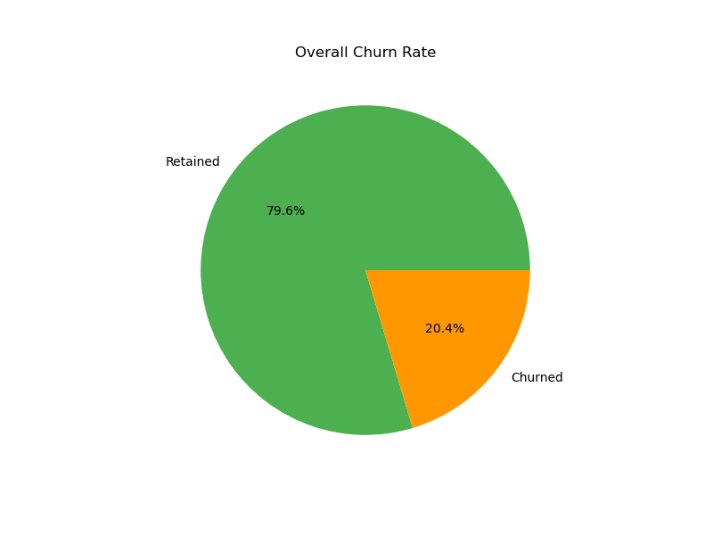

Figure 1: Overall Churn Rate
A pie chart visualization confirms the imbalance between retained (79.6%) and churned (20.4%) customers, establishing the baseline for further segmentation analysis.

  - Segment-Level Insights

    - Age Groups

Now churn was examined across age segments. The 46–60 age group showed the highest churn (~51%), while customers under 30 had the lowest (~8%).

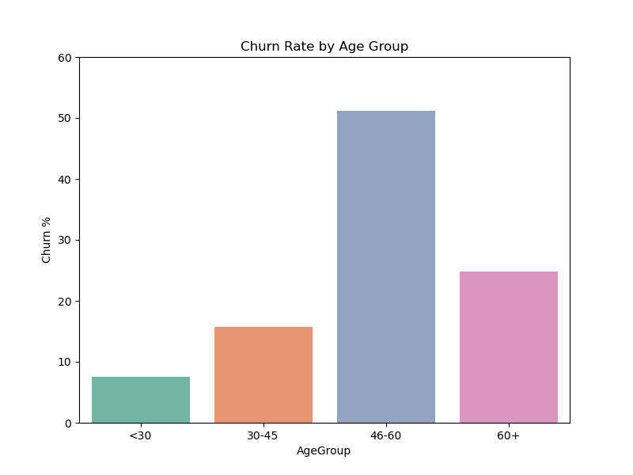
Figure 2: Churn Rate by Age Group
This indicates that middle-aged customers are particularly vulnerable, possibly due to financial or service-related pressures.

    - Geography

The EDA then explored churn by geography. Germany exhibited the highest churn (~32%), while France and Spain were both around 16%.
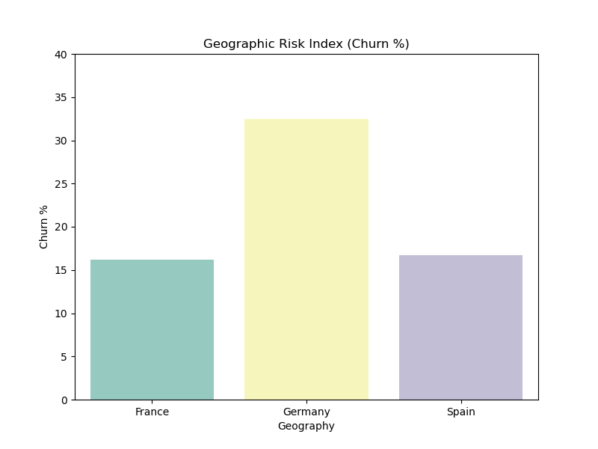
Figure 3: Geographic Risk Index (Churn Percentage)
This suggests localized risk factors, such as regional competition or economic conditions.
    - Balance Segments

Churn was further segmented by customer balances. Customers with low balances churned most frequently (~35%), while zero-balance (~14%) and high-balance (~24%) customers showed lower churn.
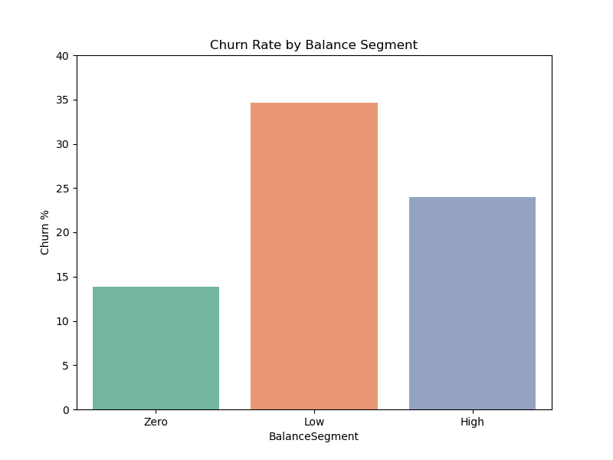
Figure 4: Churn Rate by Balance Segment
Financial vulnerability emerges as a strong churn driver.
    - Tenure Groups

The churn rates are relatively consistent across tenure segments, with minor variations.
- New customers show a churn rate slightly above 20%, indicating that early-stage engagement is crucial to prevent quick exits.
- Mid-term customers (3–7 years) exhibit a churn rate just below 20%, suggesting moderate stability but still a notable risk of attrition.
- Long-term customers (>7 years) also hover around a 20% churn rate, implying that even established relationships are not immune to churn.
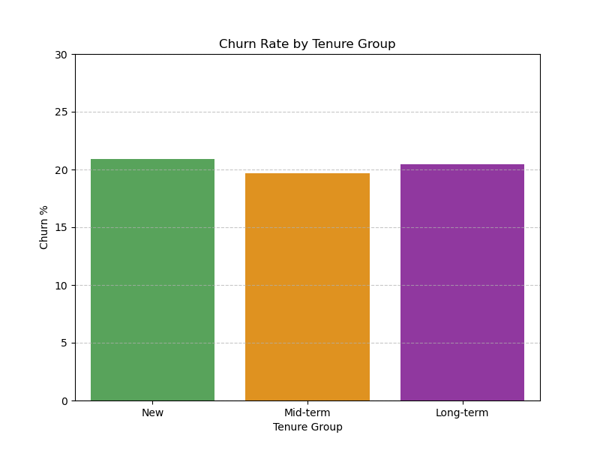
Figure 5: Churn Rate by Tenure Group
This confirms that tenure alone is not a strong predictor of churn, emphasizing the need for continuous engagement strategies.
    - Visualization Tools
- Matplotlib: Used for pie charts and static plots.
- Seaborn: Used for enhanced bar charts with color palettes and gridlines, improving interpretability.
All figures were saved as PNGs for integration into the research paper.
3.2.6 Contribution Analysis
- Age and Credit Score contributed significantly to churn volume.
- High-value customers (large balances) accounted for a substantial share of lost revenue, underscoring the financial risk of churn.
- Special focus was placed on high-balance customers. The analysis revealed 0% churn among high-value customers, compared to ~20% overall.
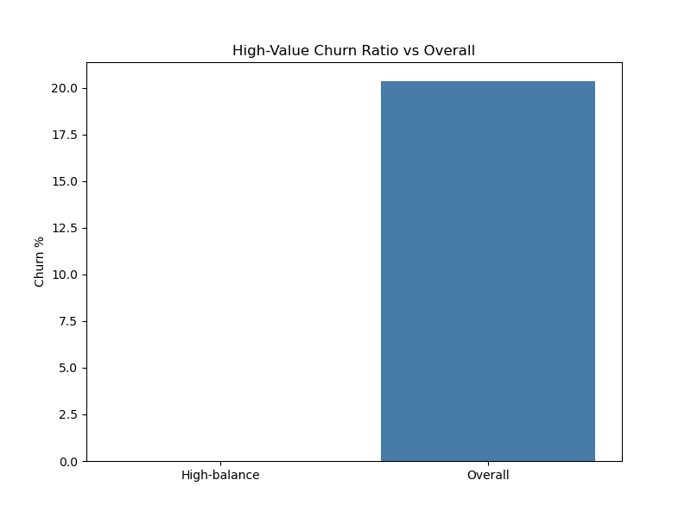
Figure 6: High-Value Churn Ratio vs Overall
High-balance customers showed 0% churn, compared to the overall rate of ~20%.
This underscores the stability of high-value customers and the importance of nurturing this segment.
3.2.6 Comparative Profiles
- Churned customers tended to have lower credit scores, fewer products, and lower engagement levels.
- Gender differences were modest but present, with one gender showing slightly higher churn risk.

3.2.7 Engagement Patterns
- Finally, engagement was analyzed. Inactive customers churned at 27%, nearly double the churn rate of active customers (~14%).
- Inactive members were far more likely to churn compared to active ones.
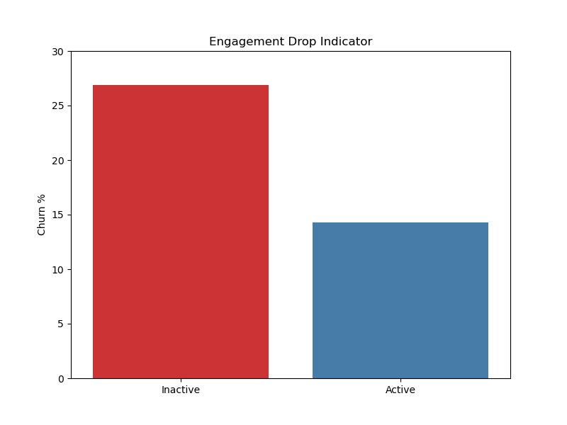
Figure 7: Engagement Drop Indicator
Inactive members churned at 27%, nearly double the churn rate of active members (~14%). This confirms that engagement programs are critical for retention.
- My Analysis
The following key takeaways summarize the most critical insights derived from this project:
- Mid-tenure, middle-aged customers with low balances and low credit scores are the most vulnerable to churn.
- Inactive customers churn far more than active ones → engagement programs are critical.
- Zero-balance customers are the largest churn group, but high-balance churners pose the biggest revenue risk.
- Geography and gender differences matter → churn prevention strategies should be tailored by demographic.
- Financial stability indicators (credit score, salary, balance) strongly correlate with churn.

- Conclusion
This project provides a clear, segmentation-driven understanding of customer churn in European banking. By uncovering churn patterns across geography, demographics, and financial profiles, it equips decision-makers with actionable insights to design targeted, data-driven retention strategies. The successful completion of this project was made possible through the guidance and mentorship of Mr. Saiprasad Kagne.
- References
- Gupta, S., & Lehmann, D. R. (2003). Customers as assets. Journal of Interactive Marketing, 17(1), 9–24.
- Verbeke, W., Martens, D., & Baesens, B. (2011). Social network analysis for customer churn prediction. Applied Soft Computing, 11(3), 221–230.
- European Banking Authority (2024). Customer retention and risk management in EU banks. Annual Report.

